**Name: Sukisivam Balakrishnan  
Superset ID:  6412333**

**Ex – 1: Setting Up Junit**

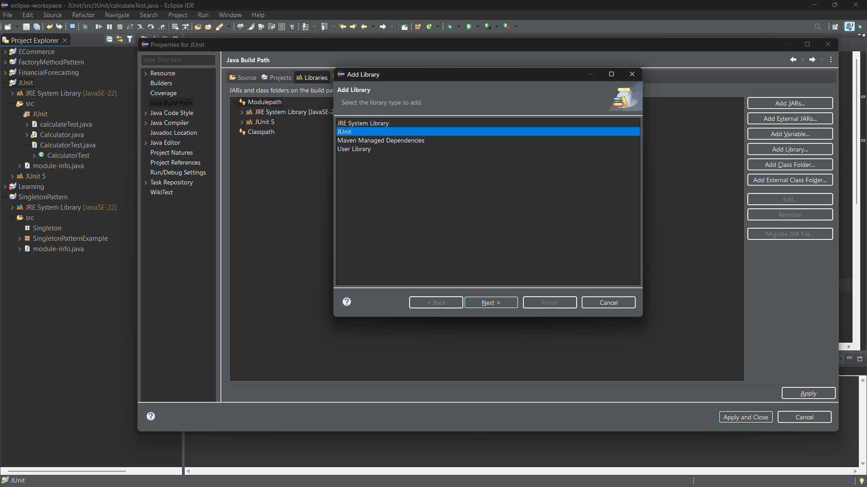

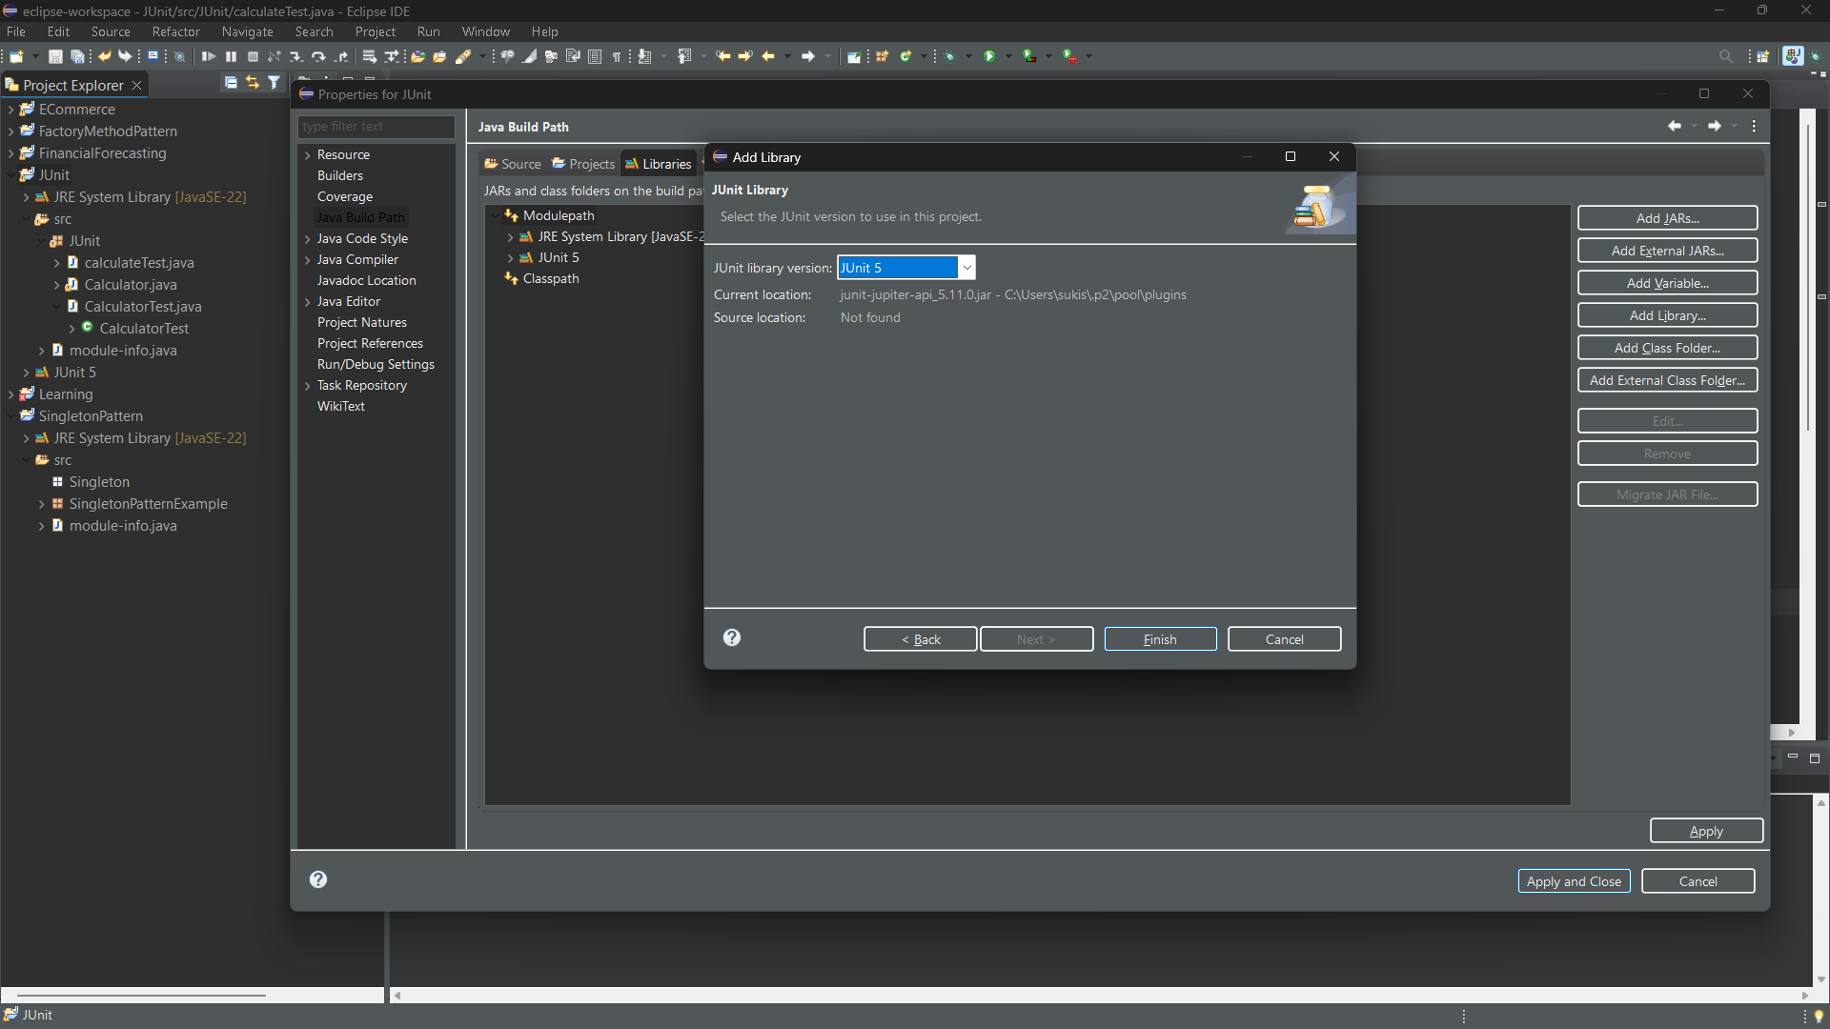

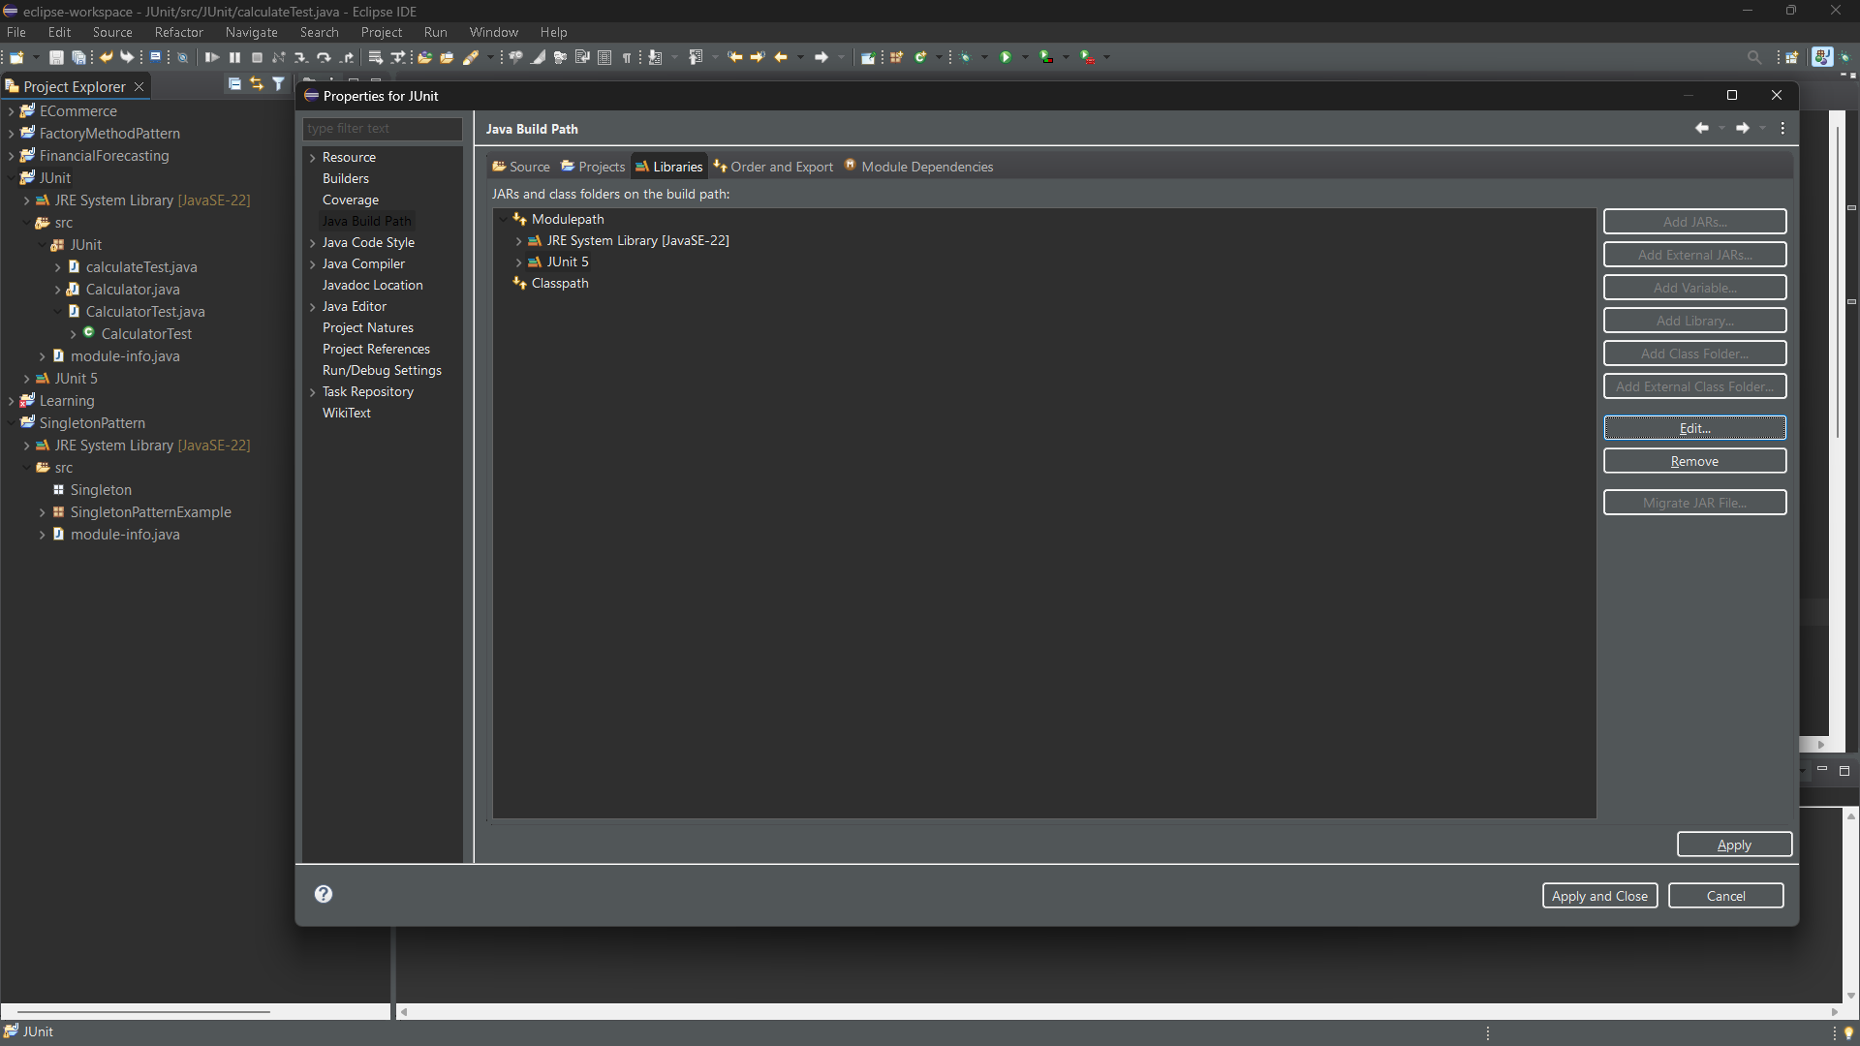

**Exercise 3: Assertions in Junit**

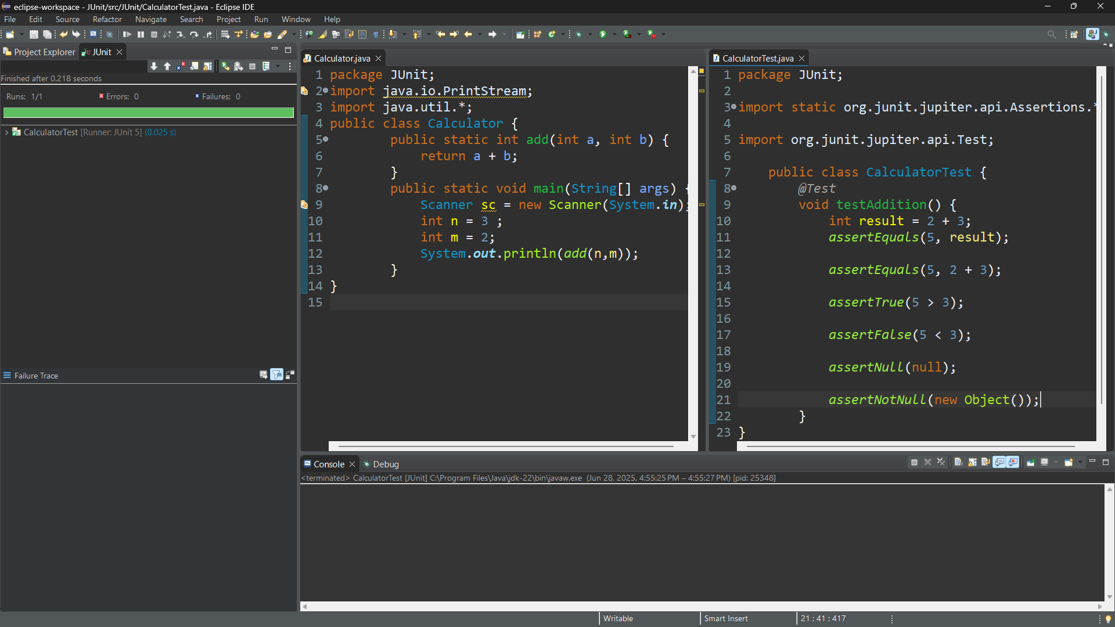

**Ex – 4: Arrange-Act-Assert (AAA) Pattern, Test Fixtures, Setup and Teardown Methods in JUnit**

